**User Guide for Kanban Board**

*Main page*

*Board view*

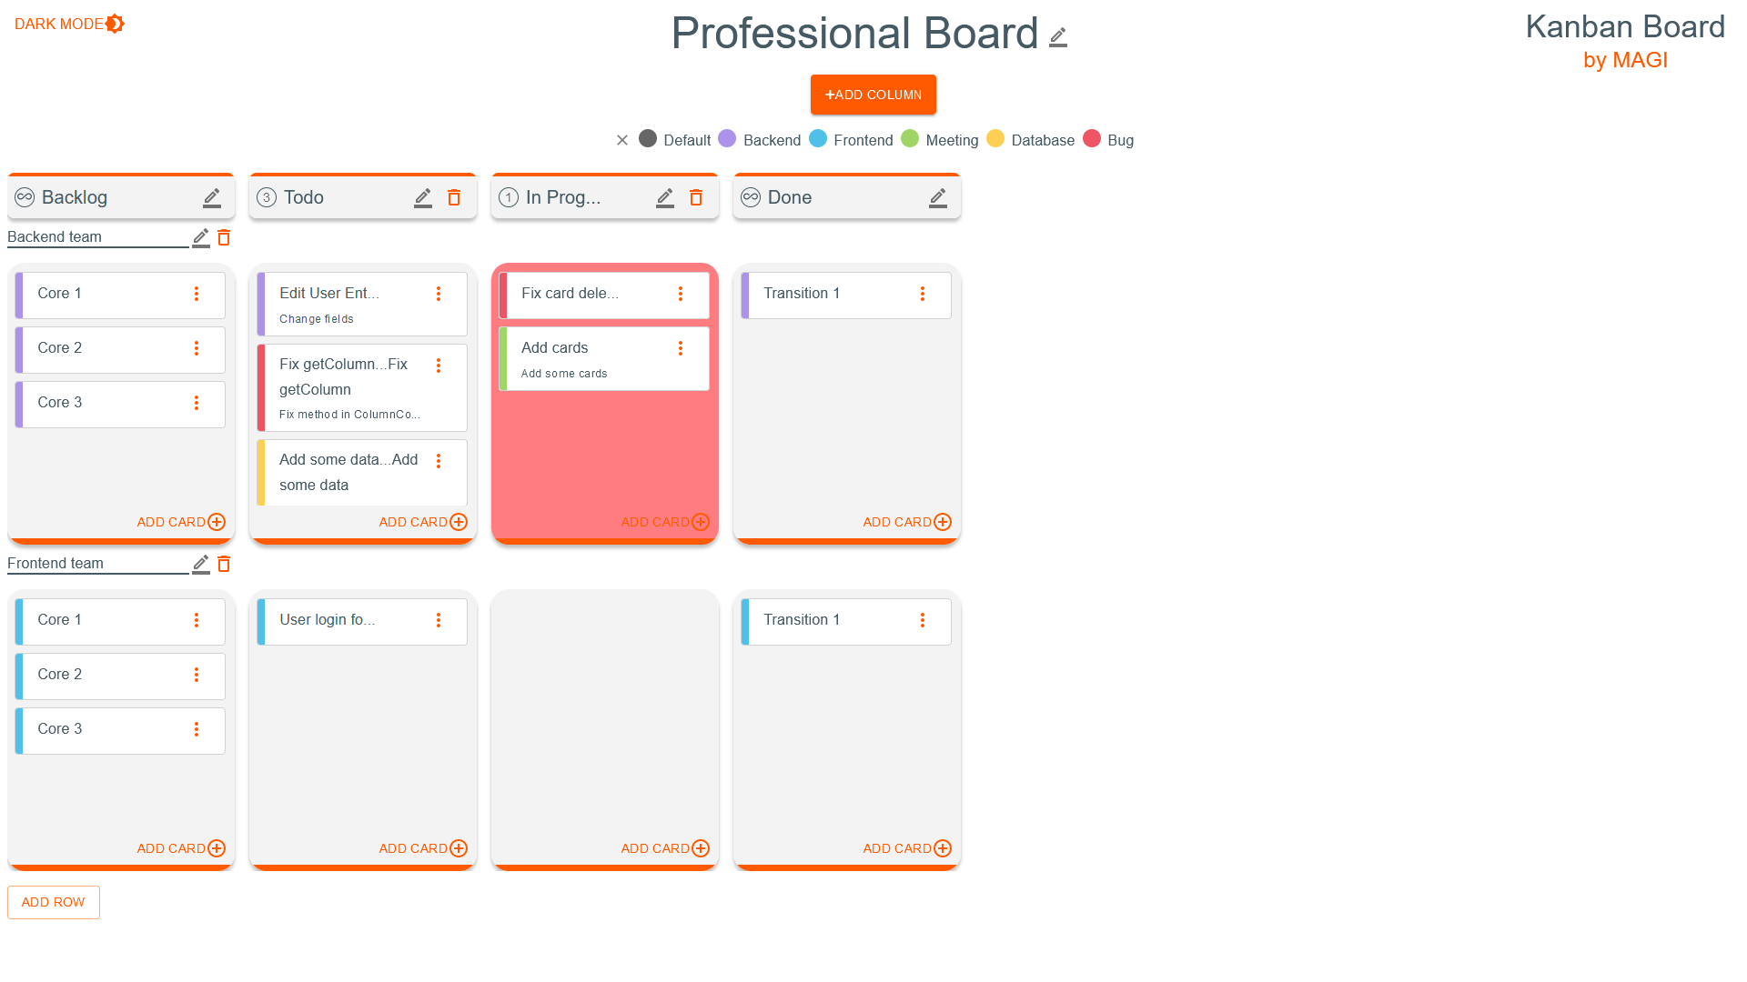

You start on the home page. To go to the Kanban board, click the login button. A login form will be displayed (temporarily it is not responsible for anything), press "Log in". You have been moved to the board. The newly created board has 3 columns, the middle one has a limit of 3 cards.

To change to a dark theme, click on the word "DARK MODE”.

1. Board-related functionalities:

* Changing the table title:   
  To change the board title, click the pencil icon next to the board title. In the window that appears, enter a new title and confirm it.
* Changing the color title in the table:   
  To change the color title in the board, click the pencil icon next to the board title. In the window that appears, tap the pencil icon next to the title you want to change. Enter a new title, then confirm it.
* Checking the color legend:   
  To check the color legend, press "SHOW COLOR LEGEND".

1. Column-related functionalities:

* Adding a column:

To add a column, press the "ADD COLUMN" button and enter the column name. The standard limit of cards in a column is 3.

* Changing the column title:   
  To change the column title, click the pencil icon next to the column title. In the window that appears, enter a new title and confirm it.
* Changing the cards limit for a column:   
  To change the card limit for a column, click the pencil icon next to the column title. In the window that appears, enter a new card limit or select unlimited. The extreme columns have an unlimited number of cards.
* Moving a column:   
  To move a column, click and hold the column you want to move, then move it to a new position.
* Deleting a column:   
  To delete a column, click on the trashcan icon and confirm the deletion in the pop-up window. When deleting a column, all cards that are in the cells belonging to the column will also be deleted.

1. Row-related functionalities:

* Adding a row:

To add a row, press the "ADD ROW" button and enter the name of the row.

* Changing the row title:   
  To change the row title, click the pencil icon next to the row title. In the window that appears, enter a new title and confirm it.
* Deleting a row:   
  To delete a row, click on the trashcan icon and confirm the deletion in the pop-up window. When deleting a row, all cards that are in the cells belonging to the row will also be deleted.

1. Card-related functionalities:

* Adding a card:   
  To add a card, press the "ADD CARD" button in the cell to which you want to add a card and enter the name of the card, and optionally it’s description. The card will appear at the bottom of the cell.
* Changing the title of the card:   
  To change the card title, click on the 3 dots icon to the right of the card you want to edit. In the window that appears, change the title and press "EDIT".
* Changing the description of the card:   
  To change the card description, click on the 3 dots icon to the right of the card you want to edit. In the window that appears, change the description and press "EDIT".
* Card color change:  
  To change the color of the card, click on the 3 dots icon to the right of the card you want to edit. In the window that appears, press "COLOR" and select the color you want to assign to the card from the list.
* Moving the card:   
  To move a card, click and hold on the card you want to move, then move it to a new position in the same cell, or move it to a new position in a different cell.
* Deleting a card:   
  To delete a card, click on the 3 dots icon to the right of the card you want to delete. In the window that appears, press "DELETE" and then confirm the deletion.